**Step in implementing the single node**

1. Login in using Putty and access your cloud based OS/Terminal
2. Changing the hostname

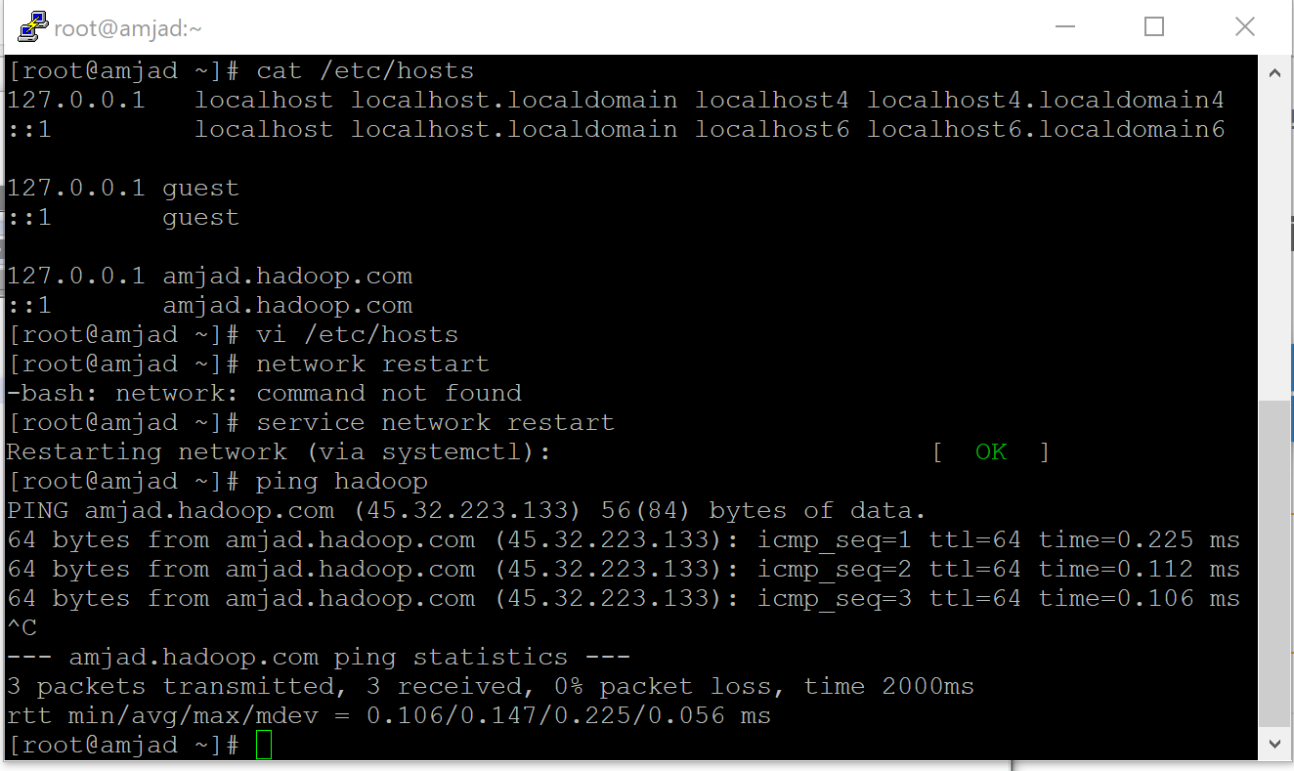

1. Downloading Java and Hadoop in Installation_files folder:

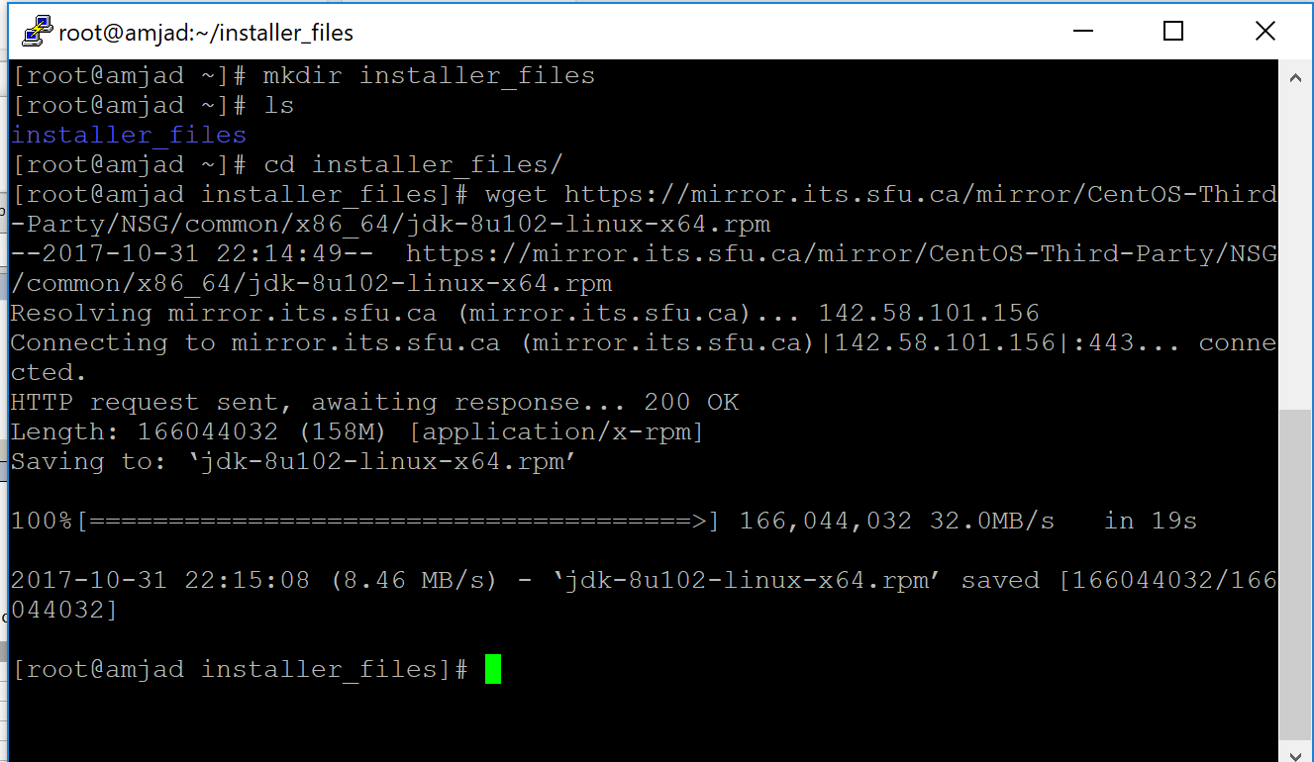

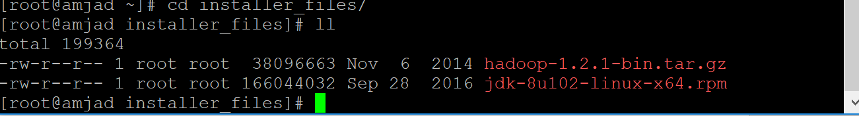

1. Editing the /Etc/Profile 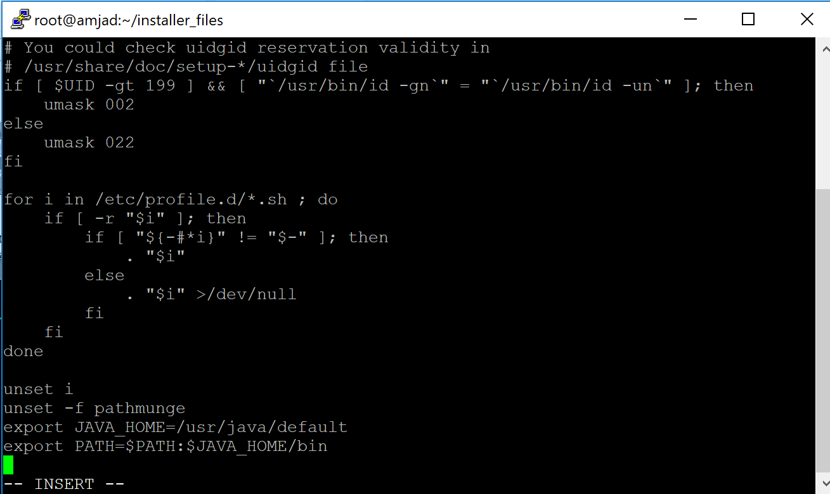
2. Generating SSH-Keygen (Access for Hduser and Hadoop(amjad.hadoop.com))

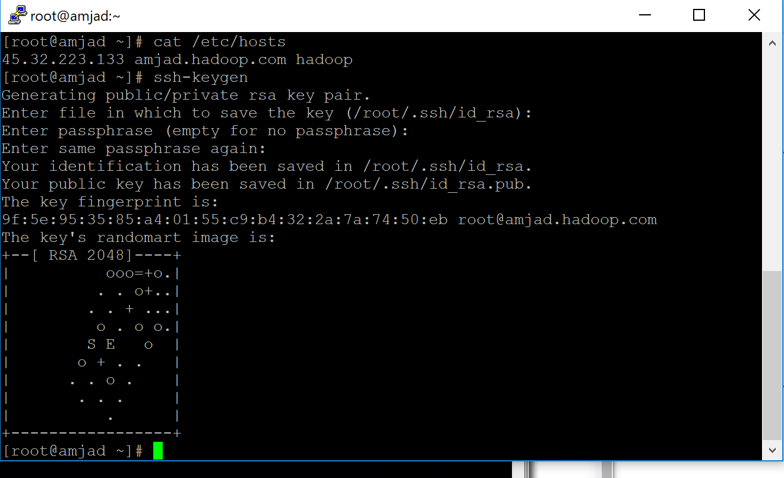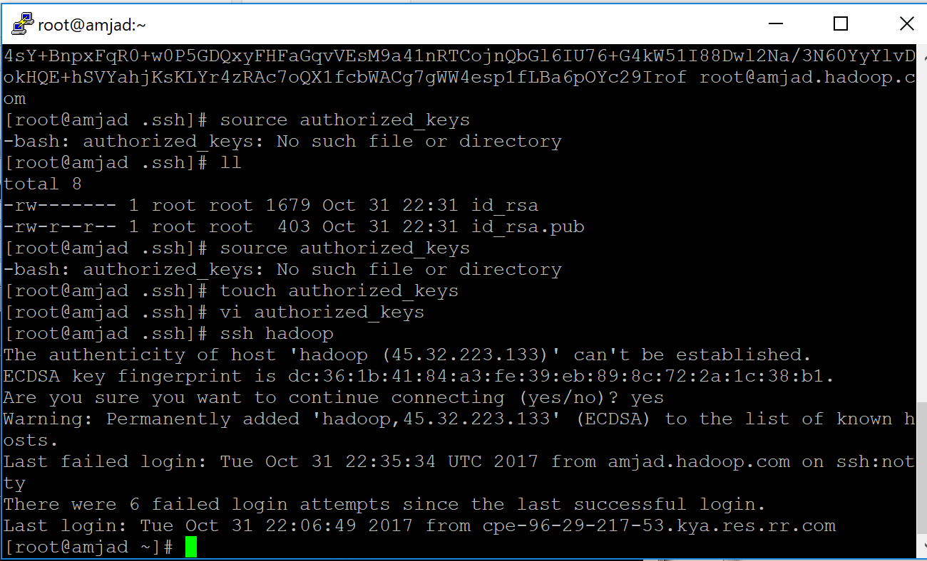

1. Creating Hadoop group (ahadoop) and hadoop user (hduser)

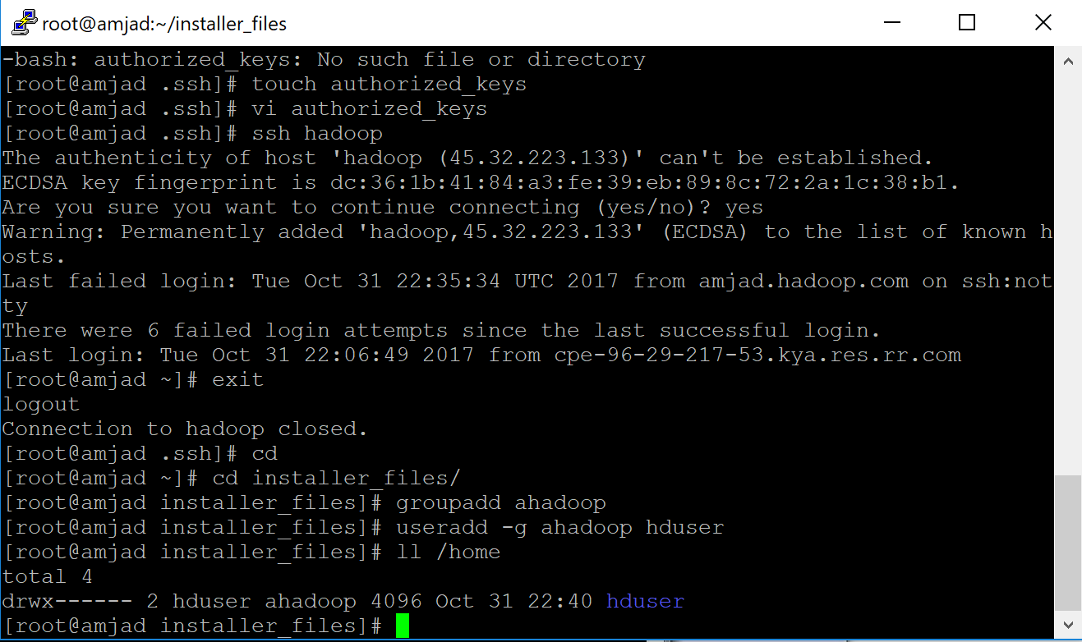

1. Setting up HDuser password and logging in as HDuser

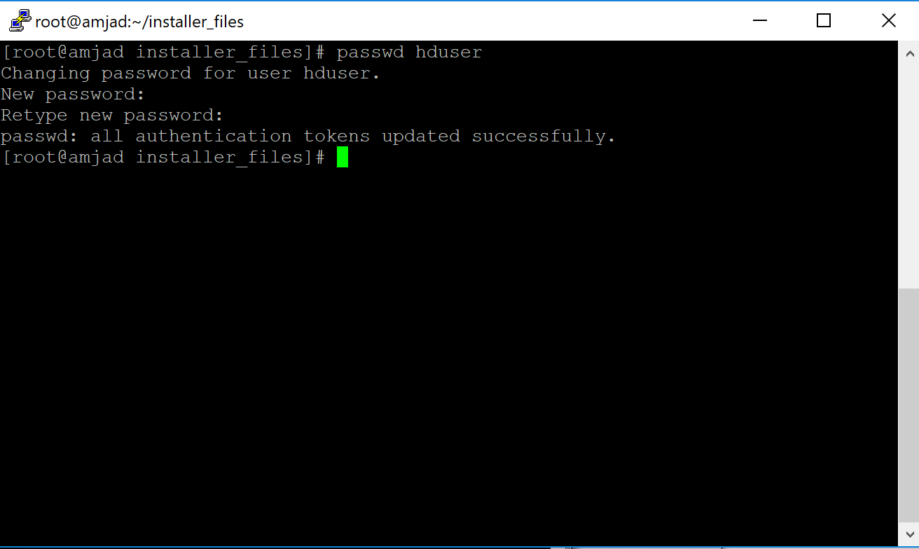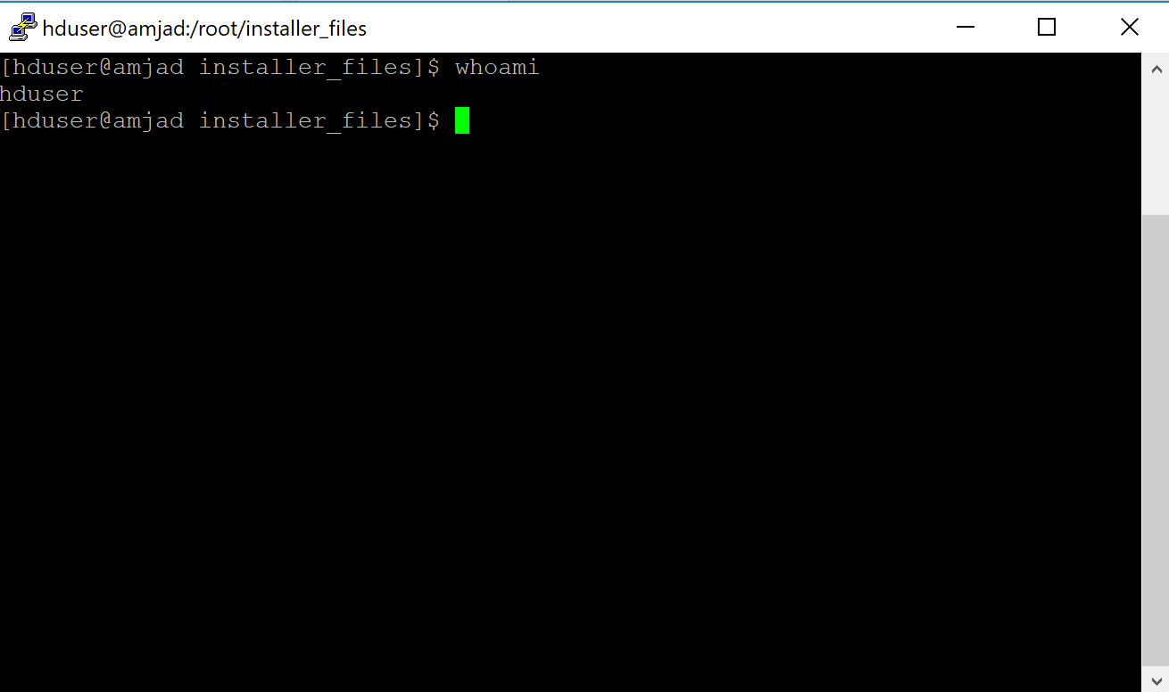

1. Doing SSH-KEYGEN in HDuser and switching the users to test

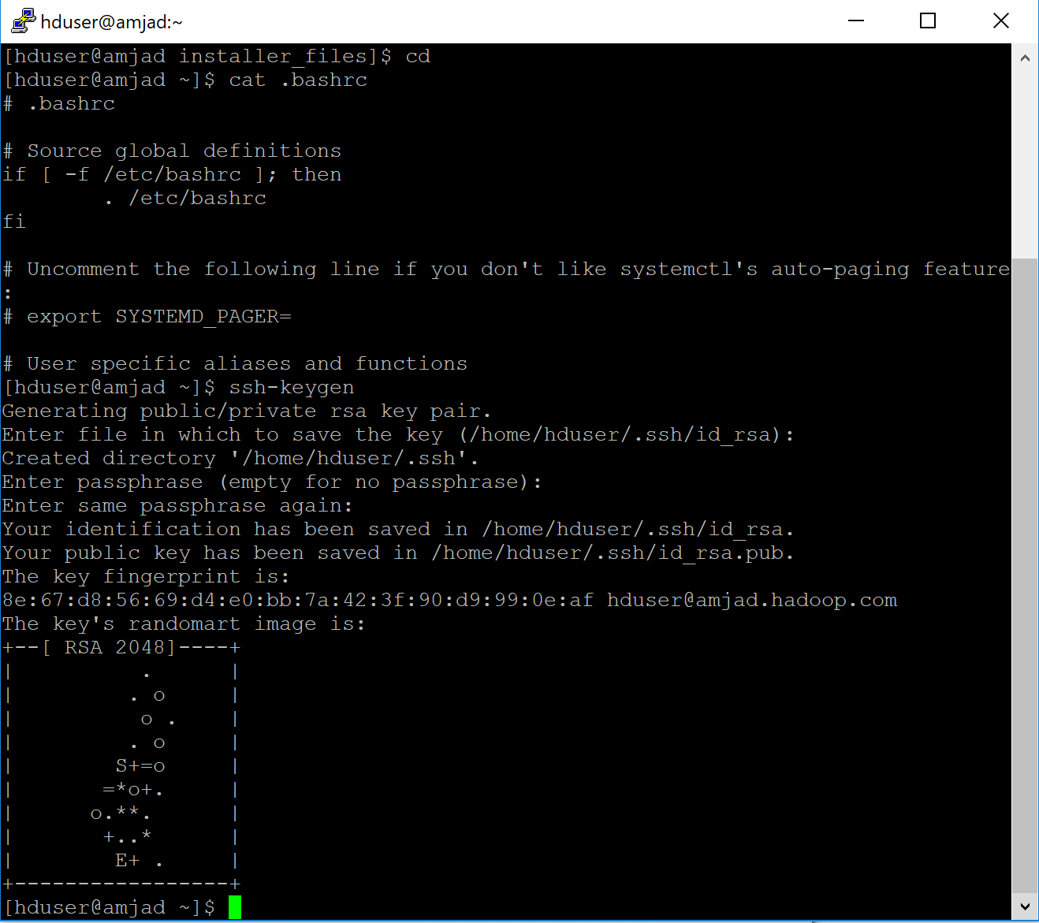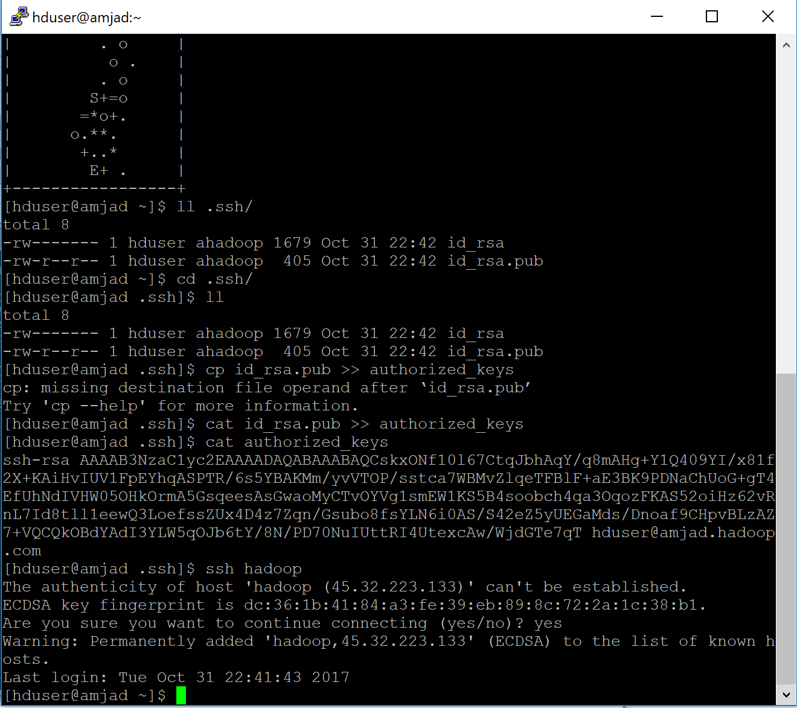

1. Creating Namenode,Datanode,Temp directories and Installing Hadoop 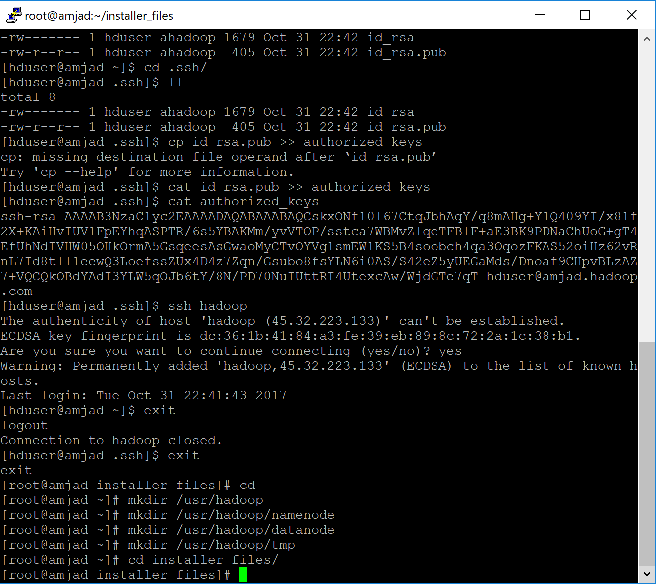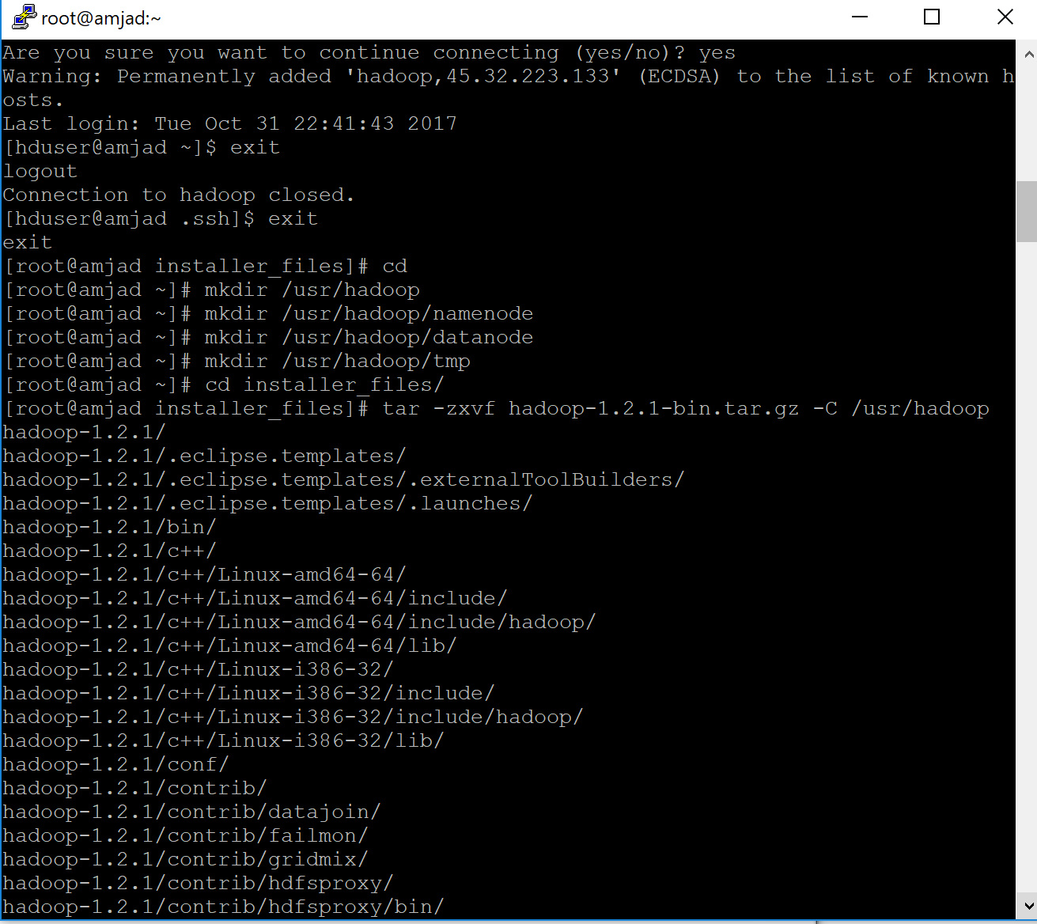
2. Setting up /user/hadoop/hadoop-1.2.1/conf Environments 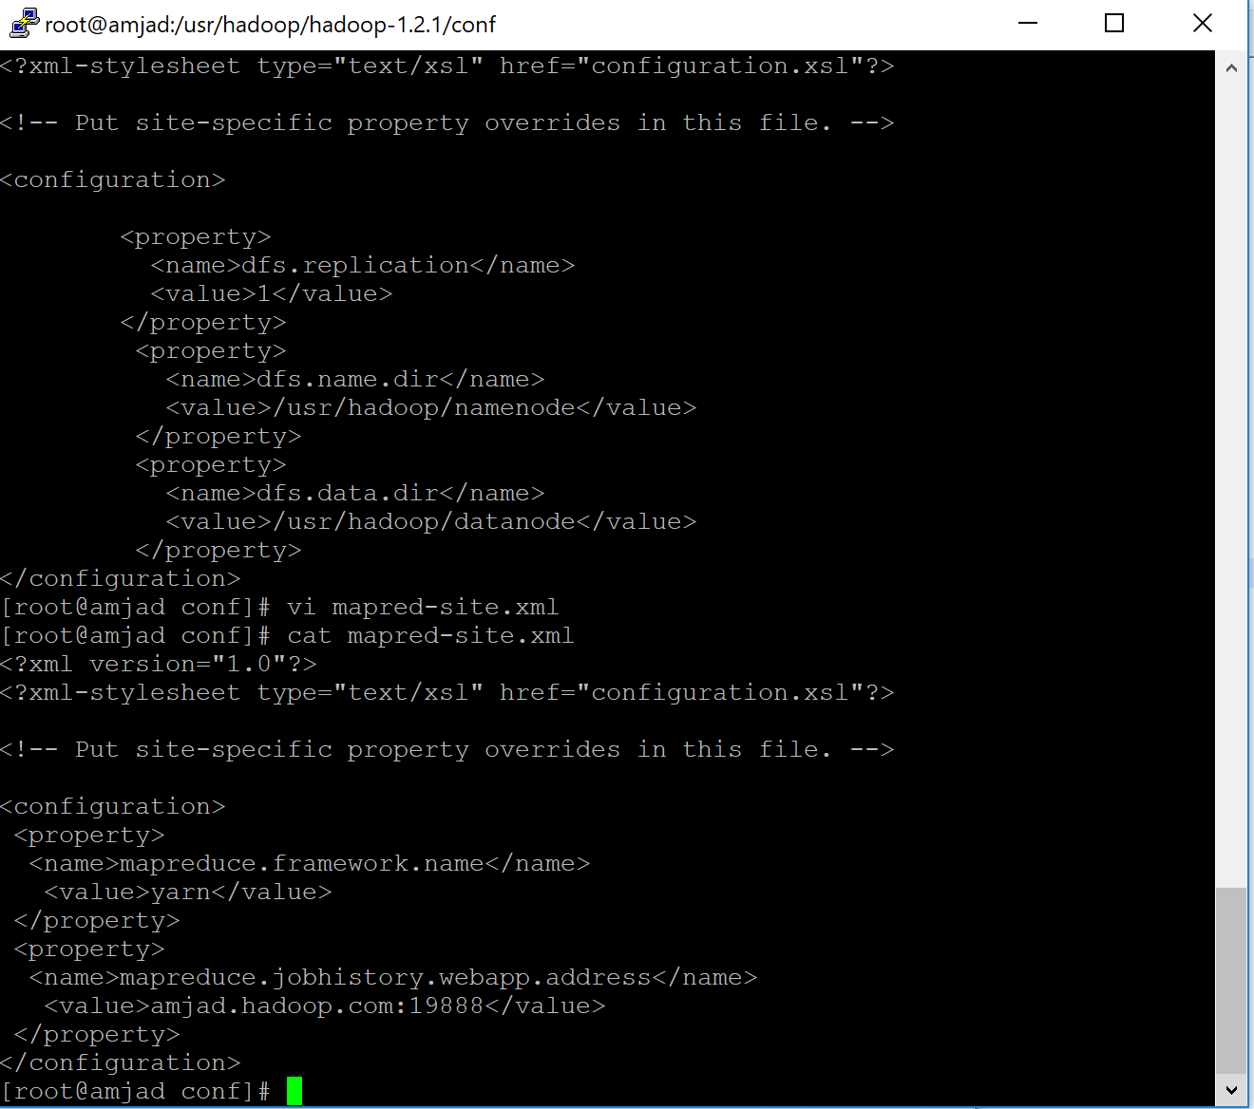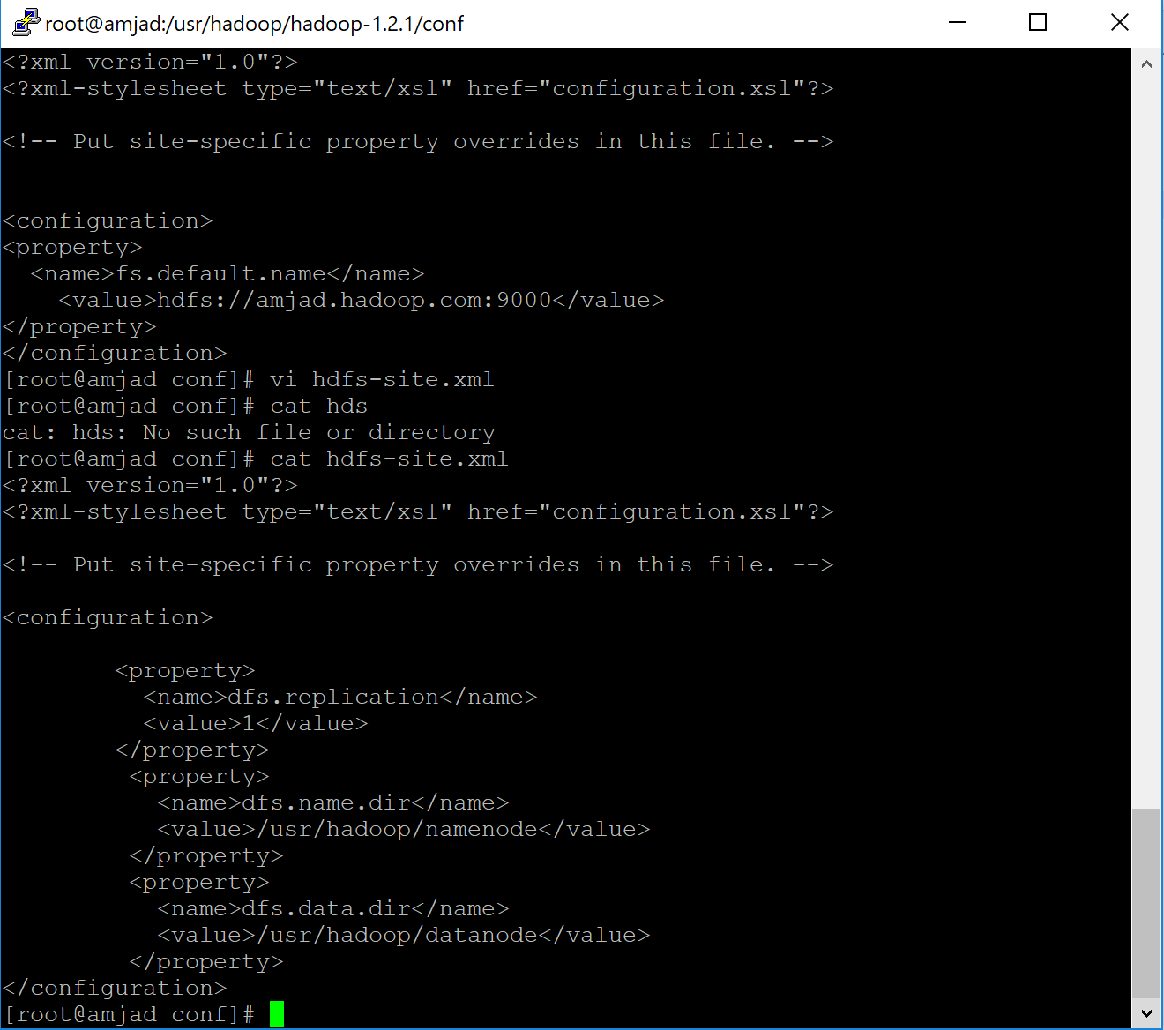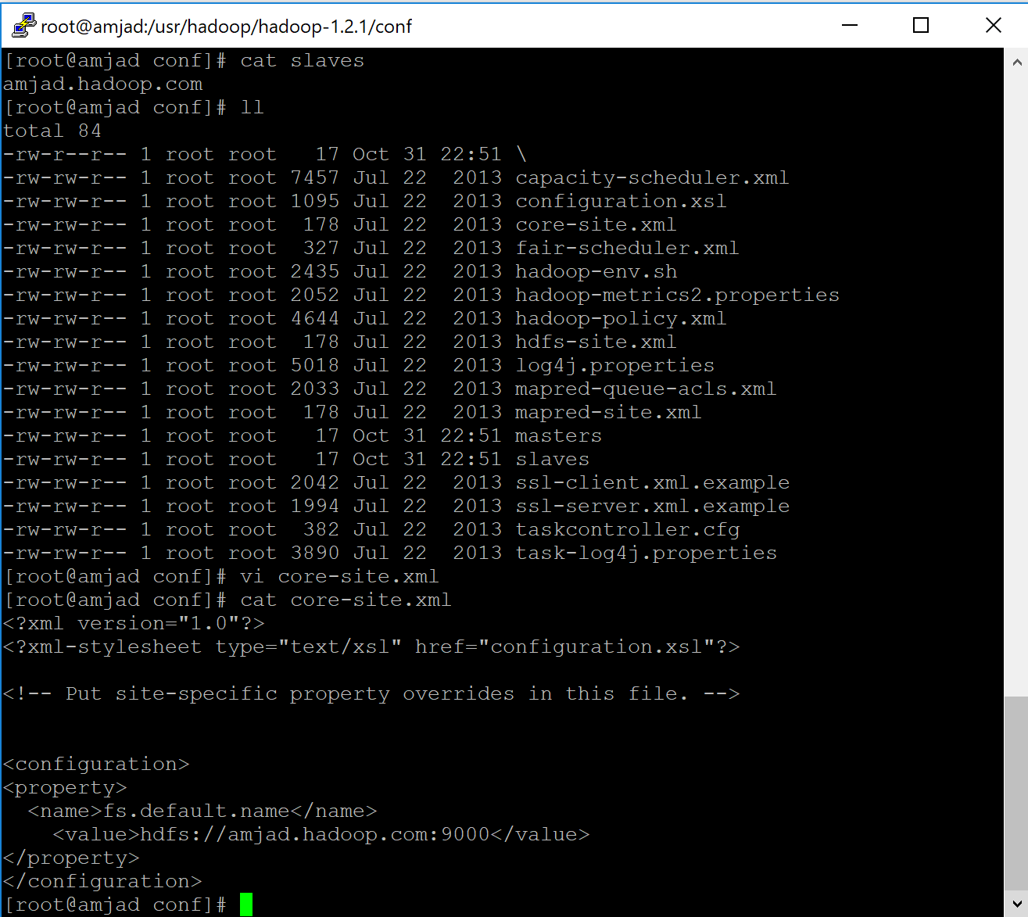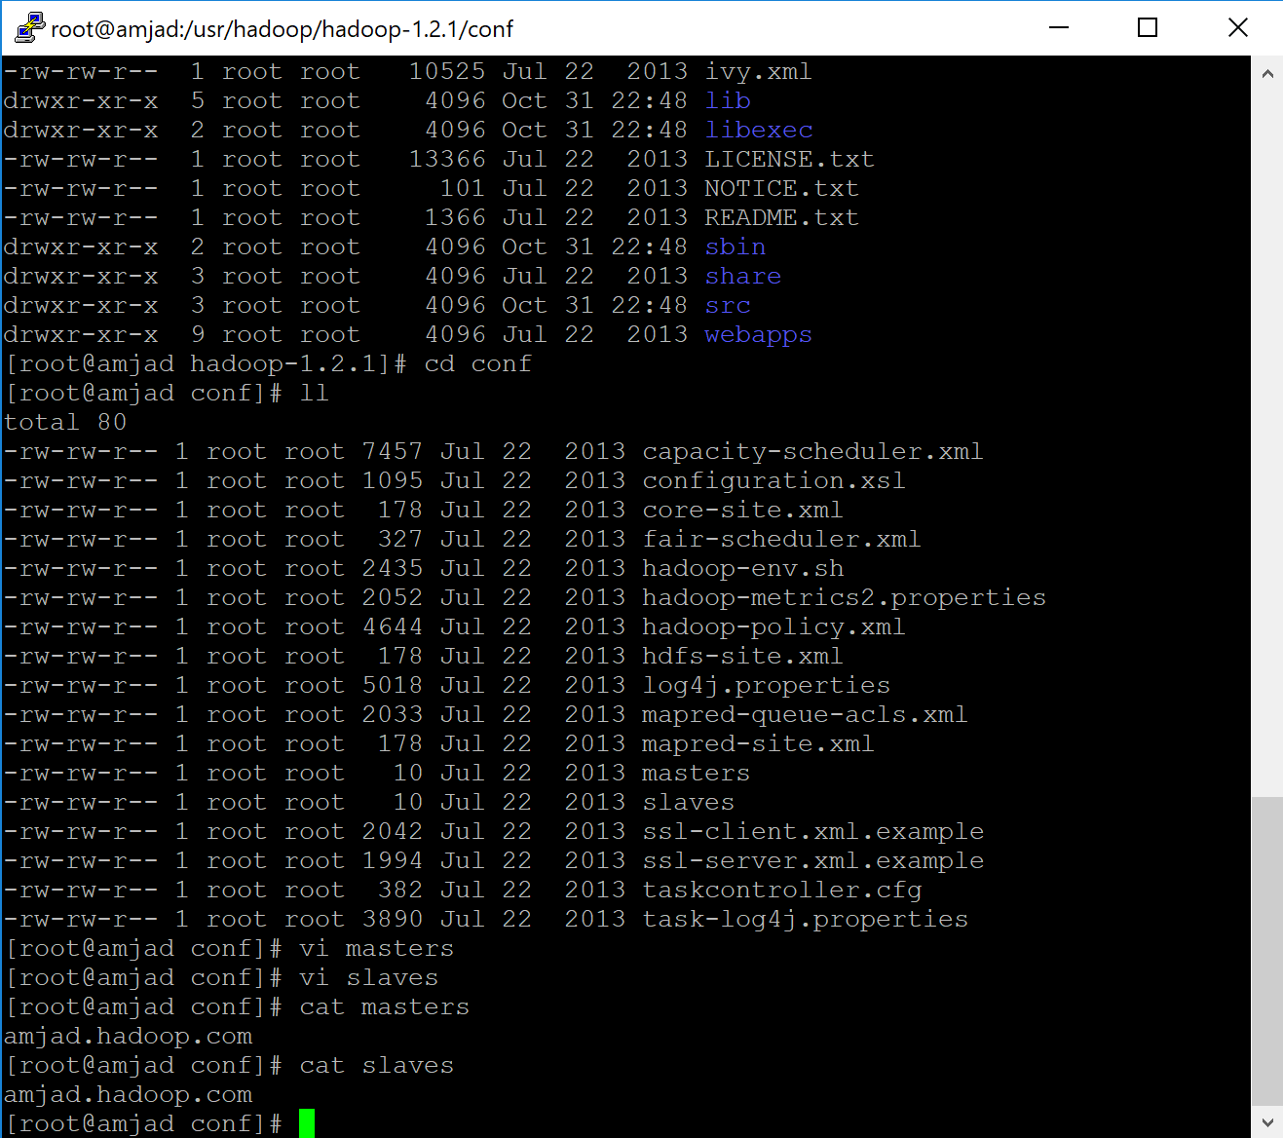
3. Editing two lines in hadoop-env.sh file

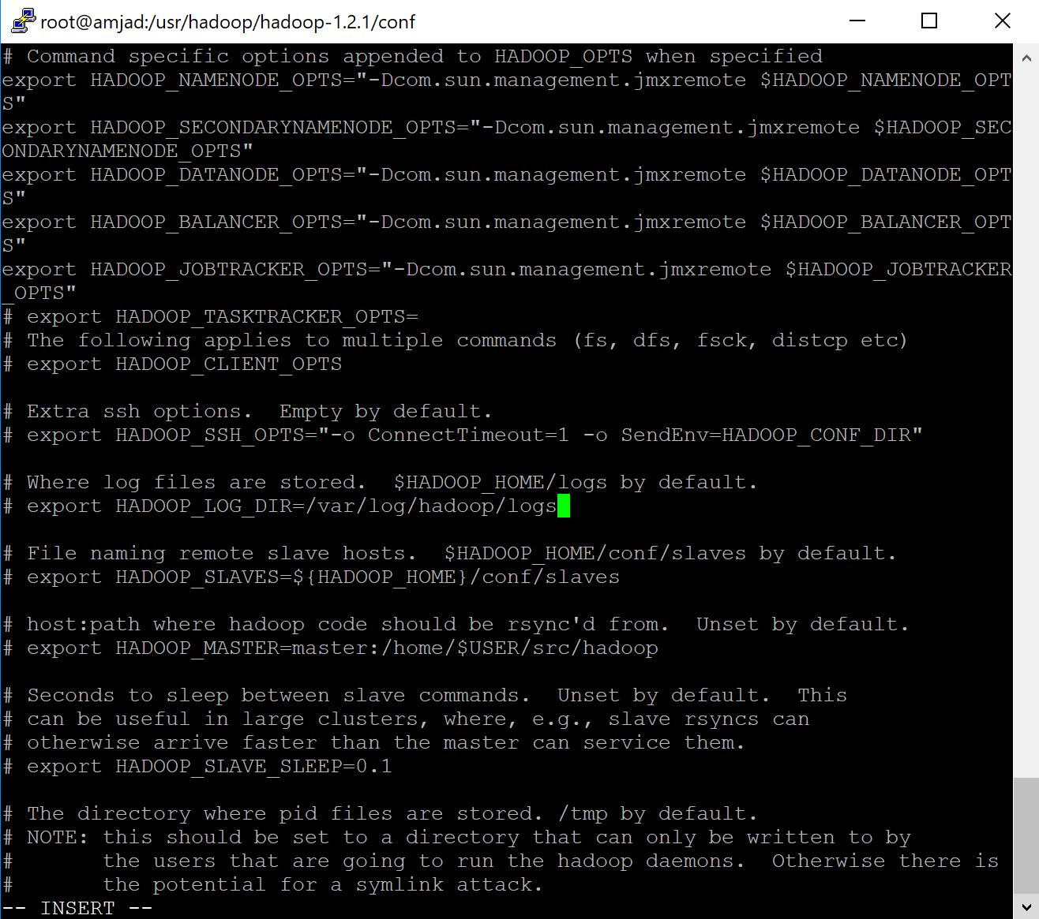

1. Giving permissions to User (hduser) and updating the profile (/etc/profile) and testing hadoop commands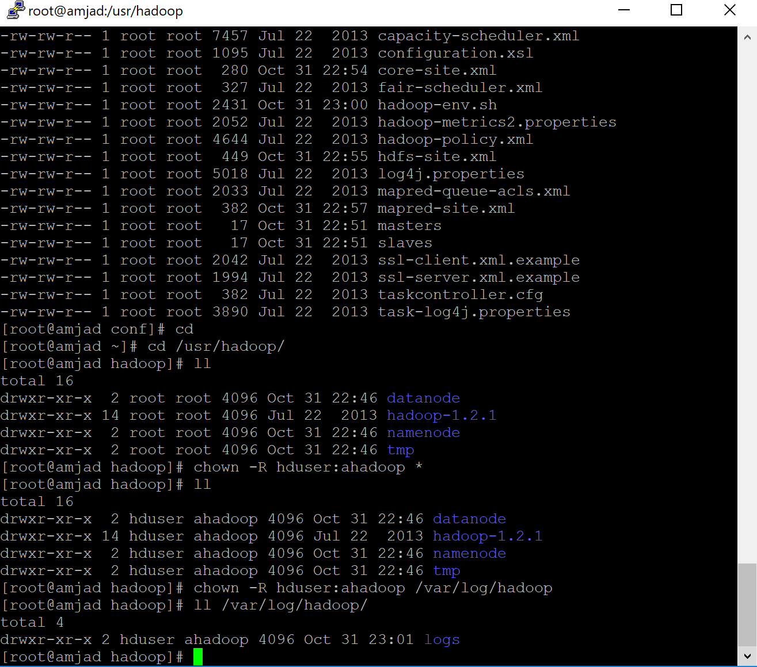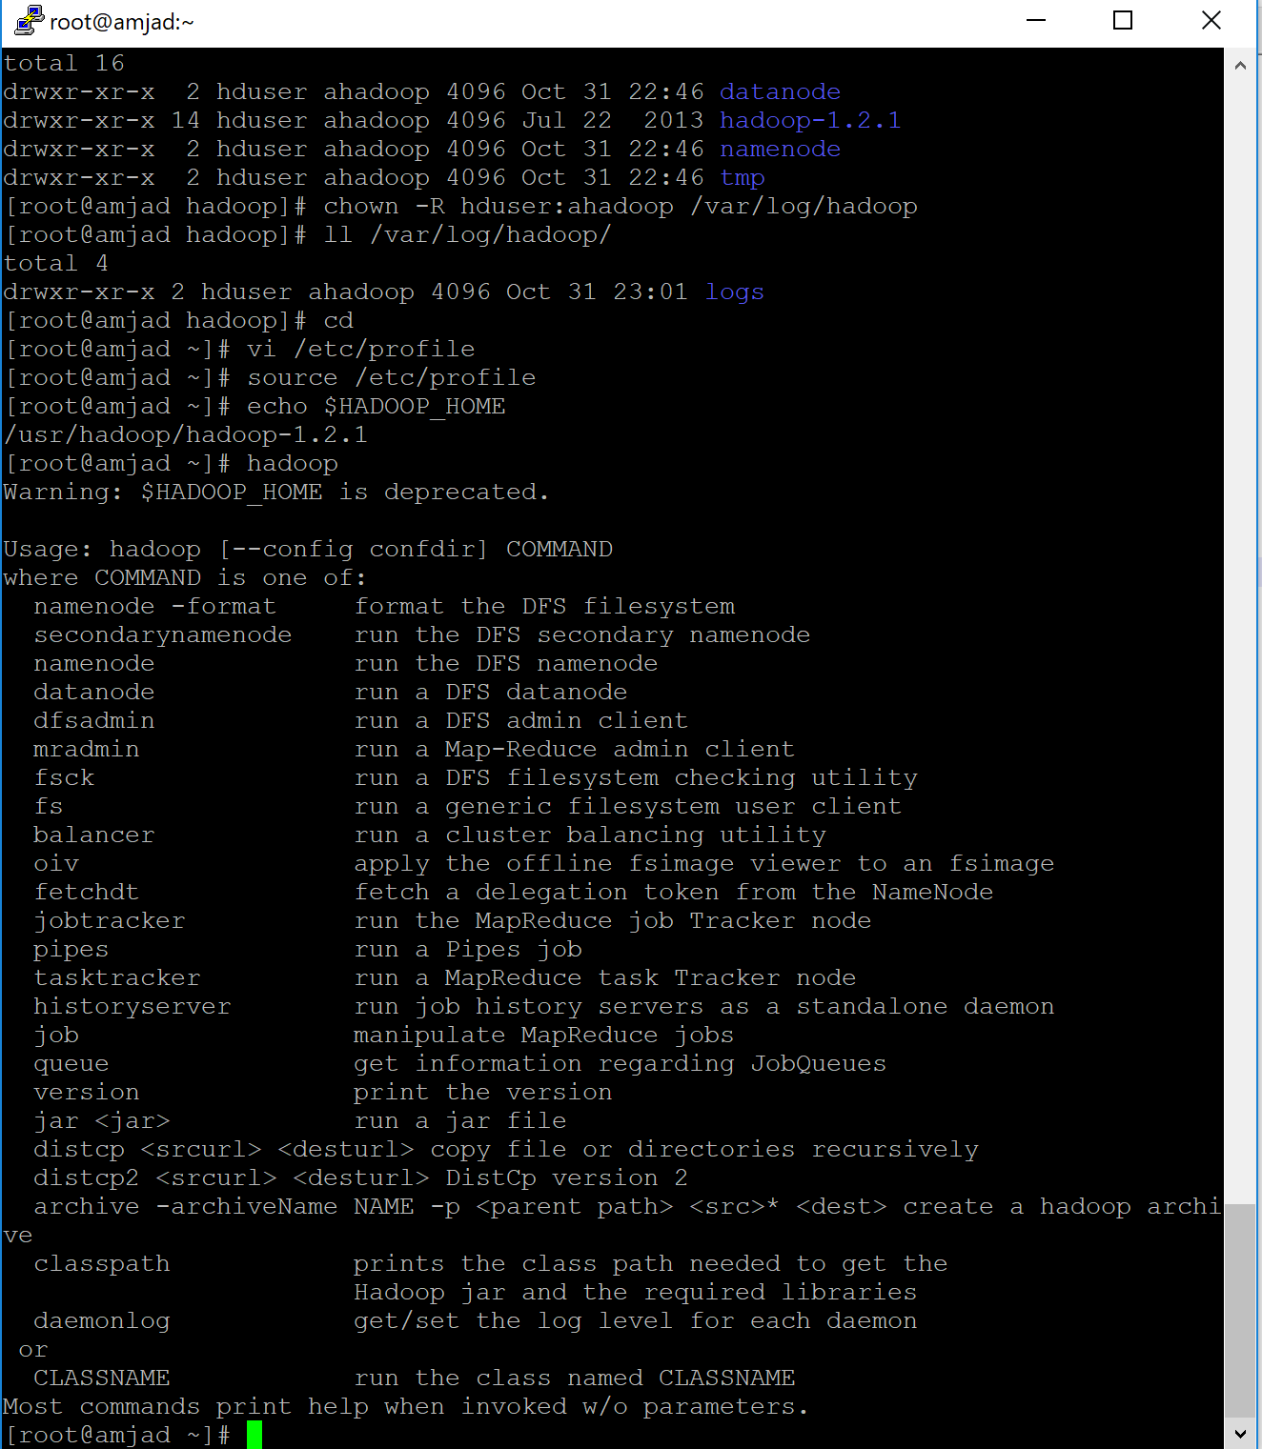
2. Format namenode

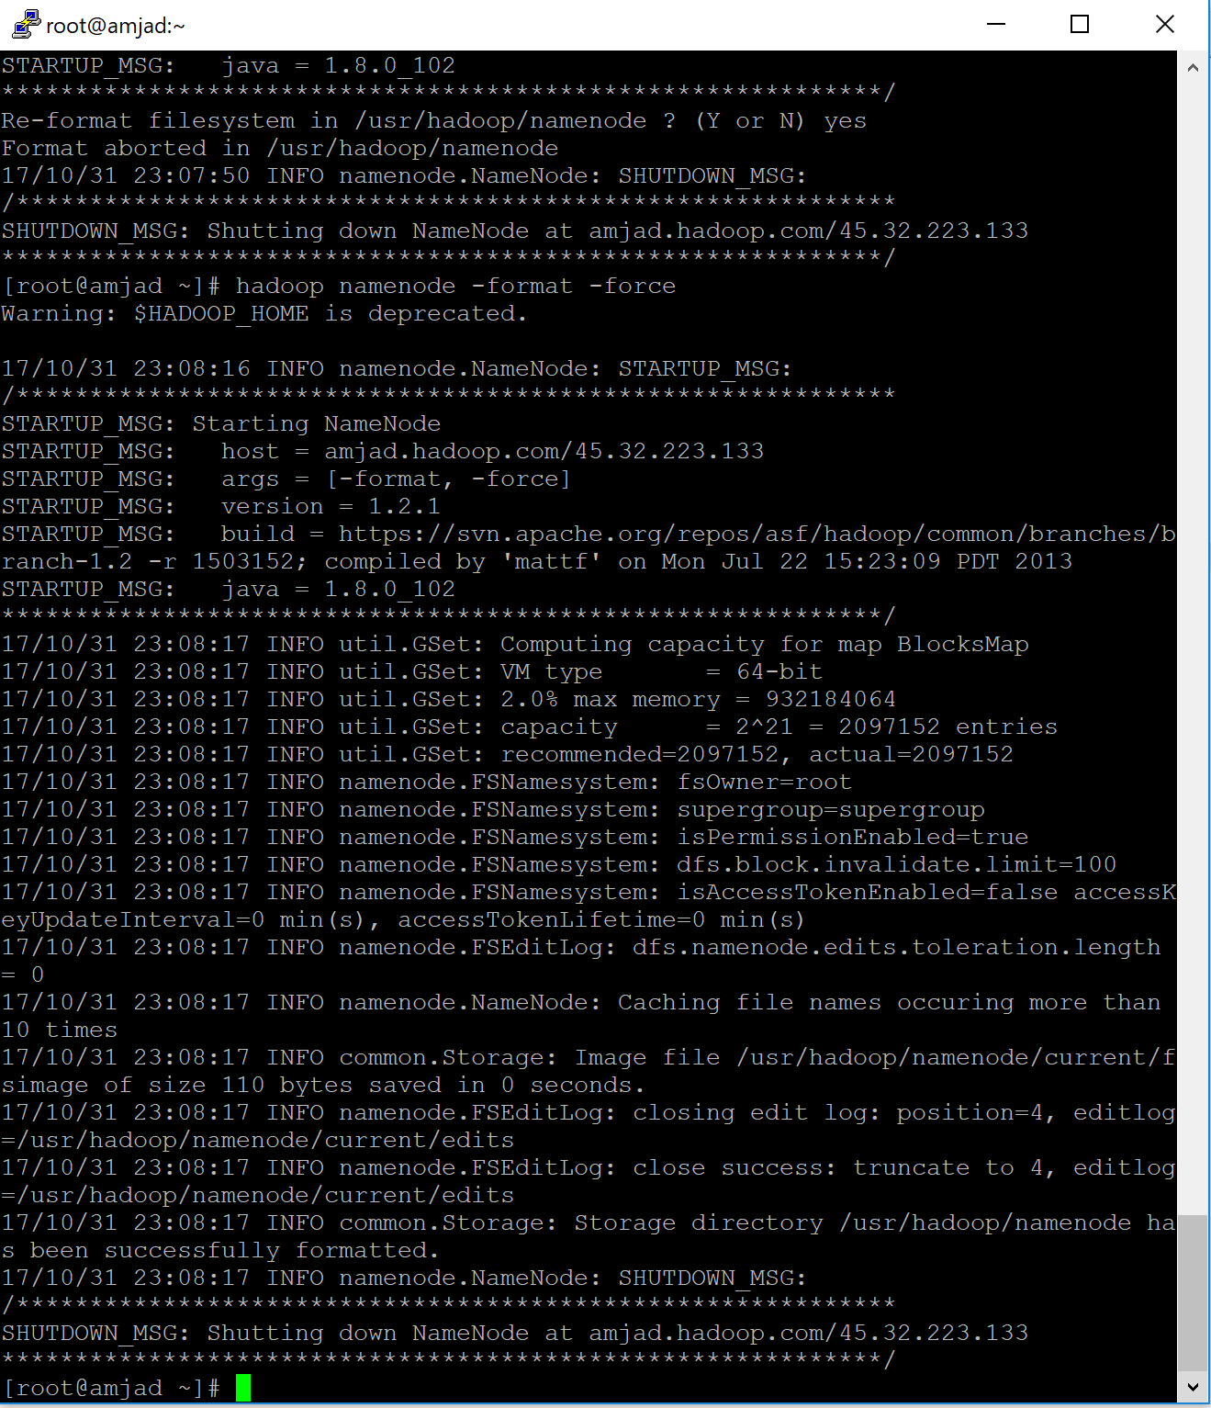

1. Going in the directory to start the Daemons

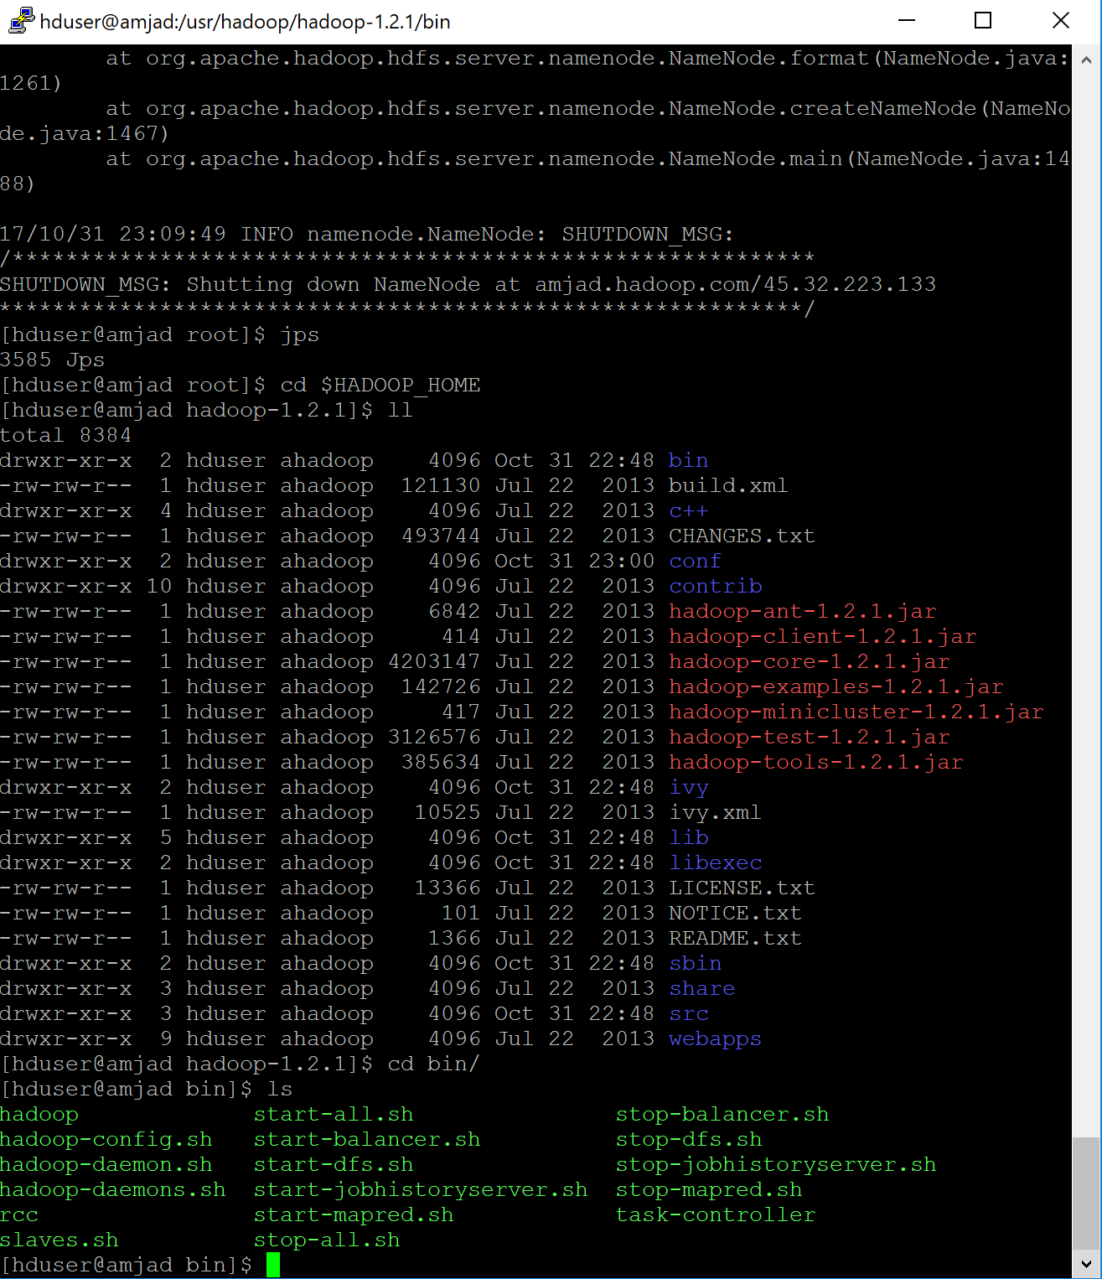

1. Checking JPS and all daemons are running

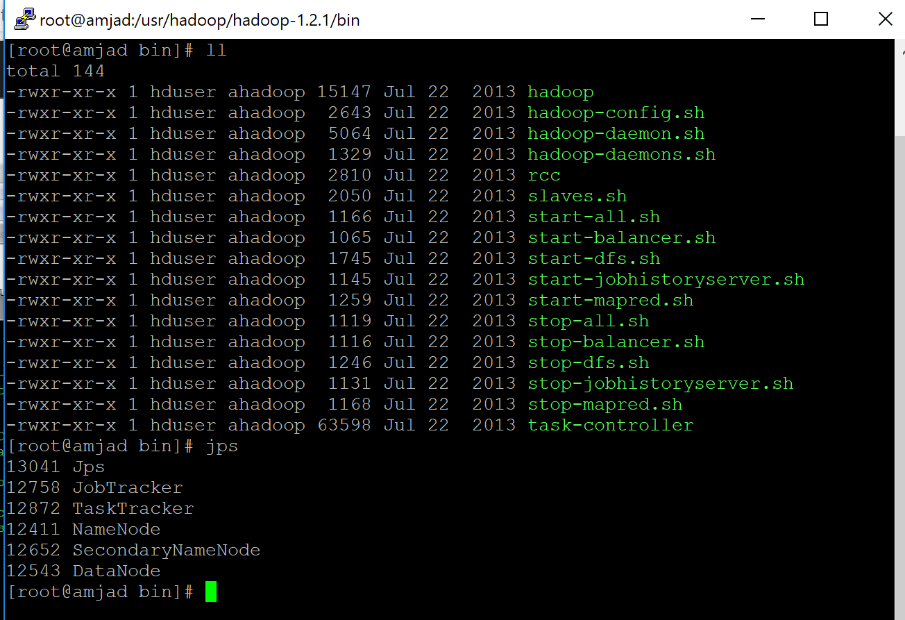

1. Accessing Namenode and Mapred via browser